Spatially selective plasma modification of three-dimensional microstructures

Simon J. Higham^{1,2+}, Sorel E. De Leon^{1,2}, Rana Jaylani ¹, Yi Jiang², Athavan Nadarajah², Toon Goris², Young Jun Jung^{2,3}, Alastair Stacey¹, Shaun L. Cloherty¹, Michael R. Ibbotson³, David J. Garrett¹, Steven Prawer², Wei Tong^{1,2,4*}

¹ School of Engineering, RMIT University, Melbourne, VIC, Australia
² School of Physics, The University of Melbourne, Melbourne, VIC, Australia
³ School of Biomedical Engineering, The University of Melbourne, Melbourne, VIC, Australia
⁴ The Graeme Clark Institute, The University of Melbourne, Melbourne, VIC, Australia
Abstract
Three-dimensional (3D) microstructures are increasingly important in biointerfaces and microelectronics applications, yet most fabrication workflows are optimized for planar structures, limiting the ability to perform precise, site-specific modification on high-aspect-ratio features. In particular, controlling plasma-based surface modification on complex 3D architectures remains challenging due to non-uniform distribution of plasma and limited spatial selectivity. Here, we present a strategy for selective plasma-based surface modification which leverages device geometry and substrate holder to confine and shape plasma around targeted sites. Combining COMSOL modelling with experimental validation, we demonstrate that in 3D microelectrode arrays, electrode length and substrate thickness can be tuned to create distinct and isolated plasma regions around electrode tips, resulting in controlled, site-specific deposition and removal of materials. Using this approach, we show both selective conformal coating of conductive carbon-nanowall (CNW) as well as conductive boron-doped diamond (B-NCD) and selective etching of Parylene-C on microelectrode arrays, creating precisely defined electrode active sites. Overall, this work demonstrates a general framework for engineering plasma interactions with 3D microstructures, offering a scalable route to additive fabrication for complex microscale devices.
1. Introduction
There is an ever-increasing demand for complex and high-performance microelectrode arrays (MEAs) for a wide range of biointerface applications, with brain machine interfaces (BMIs) representing one prominent example [1-3]. Most commercial MEAs feature 2-dimensional (2D) planar electrode geometries, where the electrodes are patterned onto a planar substrate often along a silicon shank [4-8] (Schematic 1a). The 2D geometries are typically favoured as they drastically simplify fabrication and enable reproducible, micrometre scale electrode active sites (EAS), which can be defined through standard photolithography techniques that layer conductive and insulating materials to form individually addressable channels [9-12]. While these 2D MEAs have high-channel counts, they are limited in spatial resolution to neural columns and often cause significant tissue damage when inserted due to their large cross section surface area [13-24].
An alternative to 2D shank electrodes is 3D matrix arrays (Schematic 1b), which include multiple penetrating electrodes configured in a matrix structure, similar to the Utah Array and Paradromics Array [25-29]. Matrix-MEAs (M-MEAs) allow for thinner electrode shanks that can result in reduced tissue damage [25, 30-34]. Another major advantage of M-MEAs is that they are more readily able to sample volumes of neural tissue, allowing for improved sampling of network dynamics [35, 36]. The major obstacle in manufacturing M-MEA devices is that conventional fabrication techniques, particularly those used to create EASs, such as photolithography, are not readily transferable to 3D structures.
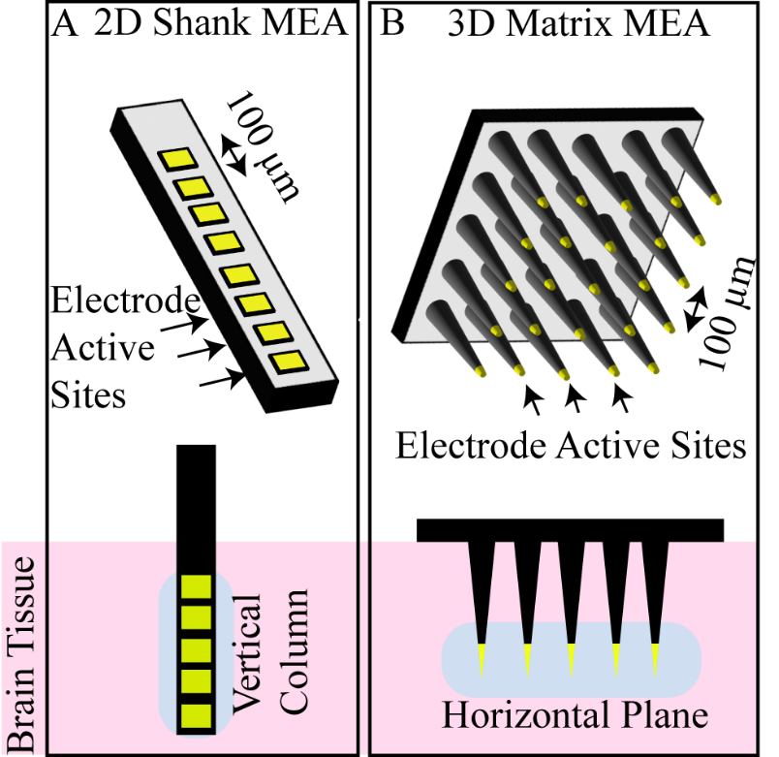
Schematic 1. Examples of 2D shank (A) and 3D matrix MEA (B) configurations as well as the targeted brain areas for each.
Plasma-based surface modification is widely used to prepare and define EASs on MEAs, enabling both material deposition of coatings and removal of insulating layers with high spatial precision. For example, reactive ion etching (RIE) is one most established technique for exposing predefined EASs on planar polyimide electrode arrays. RIE is a dry process that removes material via chemical reactions or the physical bombardment of ions generated in a plasma through a 2D mask [37-40]. The directionality of the RIE process has been extensively optimised to enable high-aspect-ratio etching relative to feature size [41-43]. However, these processes do not readily transfer to 3D structures owing to the complexity of fabricating 3D masks. For rigid M-MEAs, this limitation has been partially addressed using mechanical masking strategies, such as aluminium foil masks through which silicon microneedles are pierced exposing only the EASs [44, 45]. However, this technique is difficult to implement for flexible or more complex architectures. Performing plasma-based etching on flexible M-MEAs or other complex geometries would require advances in mask design or alternative methods that do not rely on physical masks but instead allow direct control of plasma distribution. Current techniques for selectively removing Parylene-C and exposing EAS on flexible electrodes include laser ablation or fire deinsulation [46, 47]. These methods are difficult to control or cause physical damage to the underlying electrode, especially for the laser ablation as this often results in the cutting of the underlying electrode.
Beyond surface etching, plasma assisted deposition offers an additional route for electrode surface engineering. Microwave plasma-enhanced chemical vapour deposition (MP-CVD), for example, employs a high temperature, low pressure plasma environment to chemically modify surfaces through a complex balance of etching and deposition [48, 49]. This approach has been widely explored for coating conductive diamond and other carbon-based materials onto electrode surfaces to improve their electrochemical properties, biocompatibility and surface stability [48, 50-58]. However, the success or failure of the process is influenced by many factors within the growth chamber, including temperature, gas mixture, sample and holder configuration, substrate material, chamber size and many more, creating a complex matrix that is often difficult or impossible to fully control [58-78].
Previous studies have employed holders or cages within an MP-CVD chamber to interact with, control and direct the plasma around a substrate [79-83]. This allowed plasma intensity to be controlled to either target a specific area for deposition, or to protect areas from unwanted deposition. Multiple studies have demonstrated that the use of a cage around the sample can improve the films’ uniformity and consistency [83, 84]. For example, Hejazi et al. used a titanium cage to concentrate the plasma around carbon fiber bundles during deposition of nitrogen doped nanocrystalline diamond (N-UNCD) [85]. In contrast, Ashkihazi et al. employed a plateholder design, wherein a mask with holes is placed over the sample, exposing only specific areas to the plasma [81]. To understand these effects further, Charris et al. [80] explored the effect that the holders had on substrate temperature; while, Jiang et al. utilized computational modelling to instruct efficient experimentation to allow for optimized boron doping within the diamond growth [80, 86]. Cuenca et al. also used computer modelling as a cost-effective way to explore the configurations required for optimal plasma, and then confirmed the results via experiments [87]. Together, these advances demonstrate that geometry-guided plasma control offers new opportunities for site-specific processing of complex microstructures and motivates its application to the fabrication of functional M-MEAs.
In this paper, we explore the potential for spatial control of plasma-based surface modification on complex 3D microstructures. We employ MP-CVD as a platform for both selective deposition and etching. As a representative test case, we apply this approach to deposit conductive diamond and etch Parylene-C, at EAS of an M-MEA. This M-MEA comprises multiple penetrating carbon fibre (CF) electrodes secured on an insulating diamond substrate. CFs have shown promise as chronic neural recording electrodes and are famously robust [88]. Previously, we have shown that the use of a 3D printed titanium holder could facilitate MP-CVD deposition of nanocrystalline coatings onto CF bundles [47, 85, 88-93] and the coatings could significantly improve the electrochemical properties of CFs, rendering them suitable for multifunctional neural interfacing. Confining the plasma (along with the coating) to the tips of the CF is fundamental, as our results indicated that the coating could affect the mechanical properties of the CFs [94, 95]. Furthermore, the unwanted conductive growth on the array substrates may create electrical shorts between channels, unsuitable for MEA applications. Controlling plasma around the tip of CF-based M-MEA configuration presents an opportunity to investigate localised deposition of conductive materials and controlled removal of insulating layers such as Parylene-C on complex EAS [88]. Here, we first use the finite element modelling (FEM) to investigate how titanium holders and array configuration shape the plasma distribution. We then experimentally demonstrate that tailoring titanium holder designs can selectively direct both the deposition of films onto and the removal of insulating materials from the CF tips.
2. Methods
2.1 M-MEA Sample preparation
M-MEA samples to test the plasma-based surface modification were fabricated as previously described [88]. Briefly, 2.5 mm diameter, 0.3 mm thick poly-crystalline diamond (PCD) substrates (TM100 Element Six Ltd.) were milled using a 2.5 W Nd:YAG, 532 nm wavelength, nanosecond pulsed laser micromachining system (Oxford Lasers) to create feedthrough holes for electrical connections. Individual carbon fibers were manually threaded into the holes and fixed using an Au-ABA paste with a Mo/Nb intermetallic layer, processed at 1100 °C in a MTI brazing furnace (GSL-1500X-OTF) for 30 minutes [38, 96, 97]. Post brazing, CFs were cut to their desired length using the same laser system.
For samples used for MP-CVD deposition, once fabricated, CFs were seeded with nanodiamonds to allow for uniform diamond deposition, following a protocol previously described [85, 92, 98, 99]. The electrochemical set up and electrical connections for the pre-seeding can be seen in Figure S1.
For samples used for plasma etching, CFs were secured in place with cyanoacrylate (UHU) and left to cure in air for 24 hours. This was done for simplicity instead of brazing as no electrical connection was required for electrochemical seeding. Once cured, the samples were cut to length as described above and coated in 2 µm of Parylene-C (Special Coating Systems) using a PDS 2010 LABCOTERTM 2 Parylene Deposition System (Parcoater).
Titanium sample holders were fabricated by selective laser melting (SLM) 3D-printing and consisted of a base and a lid that secure the MEA in the centre with all CFs oriented upward (Figure 1). After 3D printing, all components were polished to smooth edges and minimize unintended plasma concentration at sharp features. The square base (100mm x 100mm) was intentionally designed to be substantially larger than the array substrate (2.5 mm radius), maximizing the distance between the holder edges and the array substrate. This geometry reduces edge-induced plasma concentration near the array substrate, thereby reducing the PCD substrate exposure to the plasma and higher temperatures. To further regulate plasma distribution at the electrode tips, lids with tapered edges and thickness ranging from 0.3 mm to 2.5 mm were used to control the local deposition or etching behavior at the electrode tips.
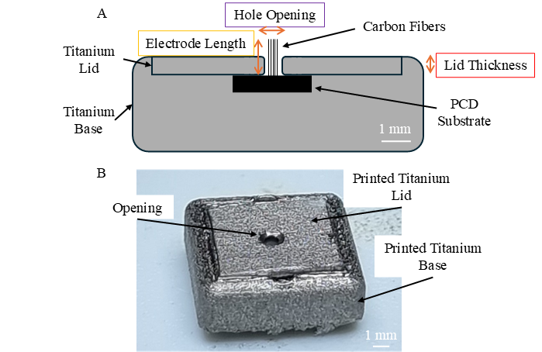

Figure 1: (A) Tianium holder configuration used in these experiments to allow for plasma shaping and shielding around the M-MEA. Parameters tested include the electrode length, lid thickness and hole opening. The 3-D printed pieces (B) show the base to hold the substrate of the MEA and lid with CF protruding through a hole for exposure to the plasma.

2.2 MP-CVD deposition
MEAs were secured in the titanium holders using titanium lids of two thicknesses (0.3 mm and 2 mm) and carbon fiber lengths (0.5 mm and 2 mm). These were then positioned on a molybdenum puck and centered within the MP-CVD chamber (Diamond Dep-BDD Seki AX) (Figure S2). For B-NCD deposition, a gas mixture of 95.5% H2, 3% CH4 and 1.5% trimethyl boron (2% boron concentration) was used at a pressure of 40 Torr for a deposition time of 60 minutes at a microwave power of 800 W and a stage temperature of 600 °C. Samples were allowed to cool completely under turbo vacuum to ensure no degradation of the titanium holders.
2.3 Plasma Etching
The titanium holder configurations (0.3 mm and 2 mm lid thickness) and electrode lengths (2 mm) were the same as those used for deposition. Two different methods for removal were used. The first being a standard RIE process, using a DRIE Multi Oxford Plasma Lab100 (gas mixture of 30 sccm O₂ and 5 sccm Ar and RF power of 10 W and DC power of 600 W). This was used as the control to compare the effect of plasma control on the etching characteristics of the parylene on the sample. MP-CVD was etched using an Iplas System with a gas mixture of 98 % H₂ and 2% O₂ was used for 30 seconds at a pressure of 10 torr and power of 600 W without stage heating. The MP-CVD chamber was cleaned using the same plasma conditions between runs. The cool down protocol was not required during this process as the limited plasma time and lack of stage heating meant the samples remained relatively cool.
2.4 Modelling
To understand the effect of electrode and lid configurations on the electrical fields within the plasma, FEM was performed using COMSOL Multiphysics, using a model previously described in Jiang et al. and Silva et al. [86, 100].
The electric field (EF) modeling was performed by finding the eigenfrequencies of the geometry of the chamber (Figure S3), with the addition of the titanium sample holder and CFs. 2D axis-symmetry was used to model the reactor chamber to save computational resources. Note that by using axis-symmetry, the sample holder is modeled to have a cylindrical shape than the rectangular shape described in Figure 1A. However, this would not significantly affect the result of the simulation. The most important part of the simulation, which is the lid and the carbon fibers at the centre of the cylindrical axis, are faithfully represented. The carbon fibers were modelled as separate fibers with diameter of 7 µm.
The electromagnetic field inside the chamber can be obtained by solving the Maxwell’s equation
$$∇×\left(\frac{∇×\vec{E}}{μ_{r}}\right)-k_{0}^{2}\left(ϵ_{r}-\frac{iσ}{ωϵ_{0}}\right)\vec{E}=0$$
where $k_{0}^{2}=ω^{2}ϵ_{0}μ_{0}$, and $ω$ is the angular frequency of the EM wave, $ϵ_{0}$ and $μ_{0}$ are the permittivity and permeability of free space, $ϵ_{r}$ and $μ_{r}$ are the relative permittivity and permeability of the medium, $σ$ is the conductivity of the medium.
A perfect electrical conductor boundary condition was employed for all the walls of the chambers, including the walls of the chamber, susceptor stage and sample holder. A coaxial microwave port at 2.45GHz with an input power of 500W was employed at the top of the chamber.
The correct mode was identified to be the TM₀₁₃ mode. Above the sample holder, an EF antinode is observed; this is where the plasma will form.

3. Results and discussion
3.1 Simulations of plasma distribution
Figure 2 presents COMSOL simulations showing how electrode lengths and holder configurations influence EF distribution within the plasma chamber. This evaluates the effects of electrode length (Figure 2A), lid thickness (Figure 2B), and the width of the lid hole opening through which the fibers protrude (Figure 2C and D). These results demonstrate that the lid configuration and CF length can influence the EF distribution, with certain designs leading to field concentration around the edges of the holder -consistent with previous reports on cage-based plasma confinement [86, 101]. The white regions indicate areas of higher EF intensity. These are prominent around the edge of the holders, which has also been observed in prior studies on distributed plasma using faraday cages [86]. According to the modelling results, arrays with longer fiber electrodes extruding from the surface of the lid show more pronounced EF at the electrode tips compared to shorter fiber electrodes (Figure 2Aiv, Figure 2B and Figure 2D). This suggests that the fibers behave like antennas, concentrating the EF at their tips.
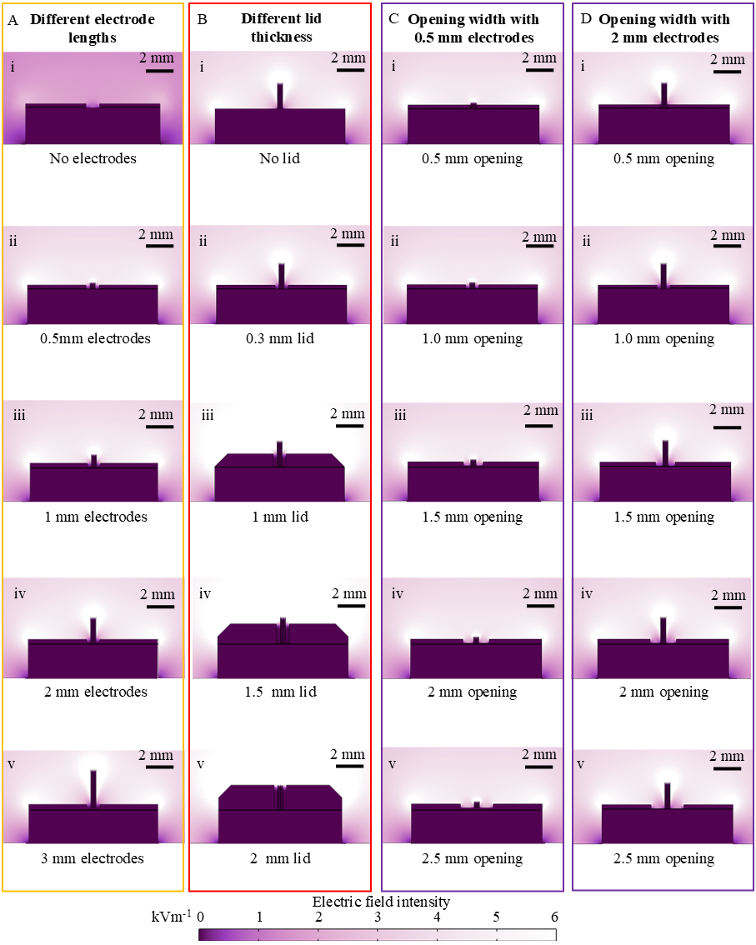
Figure 2: FEM simulations of plasma distribution upon changes of (A) electrode length, (B) lid thickness, and lid openings with (C) shorter (0.5 mm) and (D) longer electrodes (2 mm).

To quantitatively compare the distribution along the length of the electrodes, we plotted the EF distribution along the fibers as shown in Figure 3. From the figure, it is evident that electrode length and lid thickness have the greatest influence on the EF intensity, with the field increasing with electrode length and decreasing as the lid thickness increases (Figure 3A and 3B). Of particular interest is how the base of the fibers is shielded from the EF. For each of the electrode lengths modelled, the maximal EF moved further away from the substrate and the base of the electrode, with the peak of each plot being at the tip of the electrode. The EF closest to the substrate (lower distance from the base of the electrodes) can be seen in the inset of Figure 3A. With increasing electrode length, the plots remain flatter for longer, showing the longer electrodes have the highest potential to stop plasma reaching the unwanted regions on the substrate surface (potentially damaging the substrate). Figure 3B shows that varying the lid thickness (with 2 mm long electrodes) strongly affects the EF intensity at the base, with an EF near zero present in the region below the lid. Together this indicates that the lid can successfully function as a mask to spatially confine the plasma, where the lid thickness defines the masked region and only the areas protruding beyond the lid are exposed to the plasma.
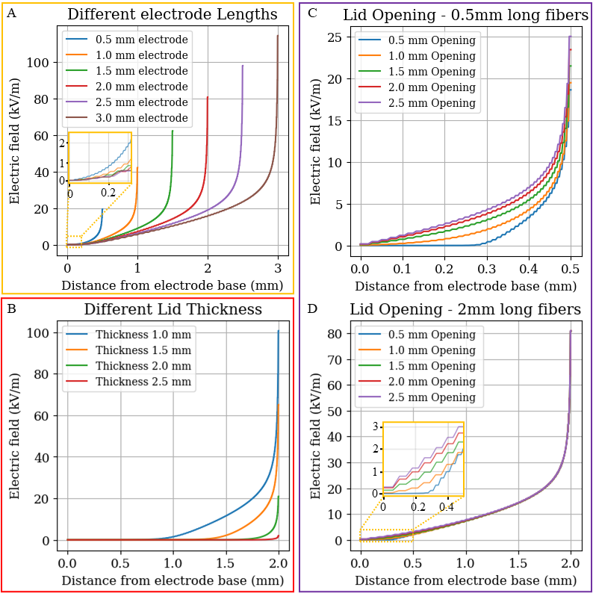
Figure 3. 2D plots of the EF distribution along the length of the electrodes as a function of distance from the base of the substrate/electrode. The different configurations compare the effect of (A) electrode length, (B) lid height and lid openings with (C) 0.5 mm and (D) 2 mm long fiber electrodes.
The diameter of the lid opening provides a unique observation of the effect of the different electrode lengths at the base of the substrate. The overall shape of the plasma distribution for the 0.5- (Figure 3C) and 2-mm (Figure 3D) long electrodes are similar, with the 0.5 mm opening appearing flat until around 0.3 mm from the electrode base. However, the magnitude of the EF is different, with the EF reaching a maximum of 25 kVm⁻¹ for the 0.5 mm long electrodes at the tip for each of the opening sizes. For the longer 2 mm electrodes, although the plots are similar in shape, the maximum strength of the EF is only 4 kVm⁻¹ at 0.5 mm from the electrode base for all plots (Figure 3D), which demonstrates that longer fibers reduce the field amplitude at the base. These results indicate that the presence of the electrodes has a more dominant effect on the plasma than the size of the opening. Potentially using smaller openings would continue to increase the distance from the base that the EF remains near zero.
The 0.5 mm diameter opening is already approaching the 0.5 mm footprint of the electrode array (5×5 at a pitch of 0.1 mm) themselves so to go lower would not be possible. The effect of the lid opening is evident when there are no fibers in place (Figure S4), further confirming that the control of the EF is achievable through the configuration of the MEA itself and the lid thickness. Having the lid cover the space between the electrodes, while it would protect the substrate, would drastically increase the difficulty of practically fabricating the device. Being able to overlay a physical mask on flexible electrodes would not be feasible, as was the aim of this work exploring alternative plasma control. The modelling results suggest that the most appropriate ways to control the plasma are through a combination of lid thickness and fiber length. By utilizing these two variables, specific and defined plasma regions should be achievable.
3.2 Experimental Validation
3.2.1 Plasma-assisted material deposition
Using COMSOL simulations as a guide, experiments were performed to confirm the ability to control plasma distribution along the samples. To this aim, a combination of configurations using 0.3- and 2-mm lid thicknesses and 0.5- and 2-mm electrodes were used. These configurations were selected as, according to the simulation results, these would demonstrate the ability of the fibers to modify the plasma conditions. Simulations also showed that changing lid opening size did not have a big impact in controlling the plasma compared to fiber length, thus we used the smallest practically possible lid opening for each sample to provide an experimental demonstration of the technique. The two configurations that contained the 0.3 mm lid with the 0.5 mm fibers (Configuration 1, Figure 4A) and 2 mm fibers (Configuration 2, Figure 4B) showed striking differences in plasma accumulation within the chamber under the same MP-CVD conditions. Figure 4Aii shows a consistent plasma distribution across the top of the holders, with some evidence of increased concentration around the corners of the holders. Figure 4Bii, although similar, shows clear evidence of plasma concentrating around the CFs themselves. This plasma distribution effect resulted in a thick bulge coating at the electrode tip (Figure 4Biii) with no evidence of coating at the base of the electrode where the characteristic carbon fiber morphology was observed or on the diamond substrate (4Biv). Configuration 3 (Figure 4C), using the 2 mm fibers and 2 mm lid, shows similar plasma distribution as Configuration 1 with no evidence of the plasma accumulation around the electrodes themselves. Using the color of the sample as a proxy to imply higher temperature zones, it appears that the samples are hottest at the corner of the holder in Configuration 1, at the tip of the fibers for Configuration 2 and surrounding the lid for Configuration 3 – which is consistent with our simulated results (Figure 4i).

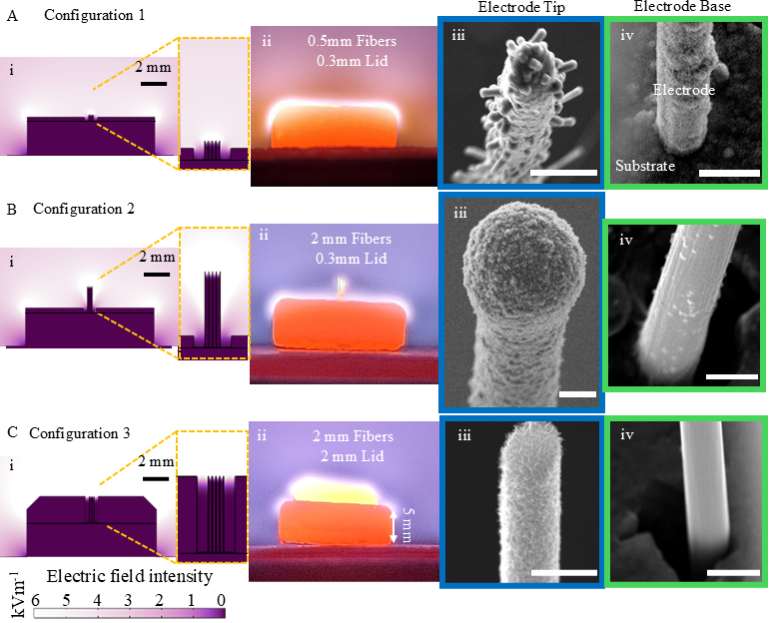
Figure 4: FEM simulated plasma (i) along with observed plasma (ii) and the corresponding SEM of the growth during MP-CVD growth showing the coating on the EAS (iii) and base of the electrode regions (iv). Configuration 1 (A) depicts a thin 0.3mm lid using short 0.5mm electrodes with growth continuing down the full length of the electrodes. Configuration 2 (B) shows an array with 2 mm long fibers with a 0.3 mm thick lid, exhibiting a clear curation of the plasma away from the substrate surface. Configuration 3 (C) shows the same fiber length as B with a 2 mm lid thickness. This too demonstrates movement of the growth region away from the substrate, with a different morphology produced. Scale bars 10 µm.
MP-CVD growth on CF to enhance its electrical and electrochemical properties has previously been shown to involve an initial carbon-nanowall (CNW) deposition phase followed by a layer of conductive B-NCD [93, 99, 102]. CNW consist of 3-D vertically orientated graphene sheets wherein the B-NCD consist of more diamond-like bonding in the nanocrystalline carbon structure [103]. Both coatings have shown promise for neural stimulating, recording and electrochemical sensing electrodes [85, 92, 93, 104]. This is useful as a guide for estimating the different growth rates in each region on the electrode. Regions with slower growth rates or lower temperatures are more likely to contain a CNW morphology, whilst other regions that appear more B-NCD-like are likely to be where the plasma concentrates. It is not confirmed that the growth rates will be consistent throughout the chamber; therefore, at different times, we expect to observe a linear change from CNW to BNCD-like. However, the varying morphology of the deposited layers does serve as an indication of the distinct growth regions.
The two main areas of interest for the coating are the electrode tips and the base of the electrode (Figure 4 iii and iv, respectively). To create a functional M-MEA the growth must not extend to the base of the substrate, as deposition of this conductive material can create shorting or damage between different electrodes on the M-MEA. If shorting occurred, it could potentially be removed after the process, however, due to the complex geometry of the M-MEAs and the fact that both the coating and the underlying CF share similar chemical composition, any physical or chemical removal techniques are likely to have unwanted effects on the CF. This could be of less concern for M-MEAs created using other flexible microwires, but for carbon-based electrodes this is a fundamental issue. This work aims at simplifying already complicated processes, so the achievement of distinct growth regions is preferred to post processing. The gold braze on the backside of the substrate was minimally affected (Figure S5). Electrical shorting was observed after the process, with resistance detected in kΩ range between opposite corners of the substrate. This shorting could be resolved (with resistance increased to MΩ range) using an oxygen plasma cleaning process (Zepto M2 plasma cleaner from Diener Electronics using a gas mixture of 90% oxygen and 10% argon, power of 40 mW and a pressure of 0.7 Torr) for a period of 1 hour. The plasma cleaner only removes surface layers, so the dramatic increase in electrode-electrode resistance can be attributed to the removal of surface contamination rather than etching of the deposited diamond
Configuration 1 (Figure 4 A) shows a clear presence of CNW on the base of the CF (Figure 4Civ) with what appears to be a more B-NCD-like coating on the tip of the electrode (Figure 4Ciii). This configuration showed minimal evidence of plasma concentration around the tip of the electrode. The thin lid of the holder has acted as a mask to separate the substrate from the bulk of the plasma. However, due to the presence of the hole in the lid for the CF to sit through, the substrate at the base of the CF has been exposed to plasma. As suggested in the modelling (Figures 4Ai, 3A), there appears to be a small difference between the intensity of EF at the tip compared to the base of the electrodes. These experimental results indicate the level of EF control away from the base was insufficient to shield the substrate from the plasma conditions required for growth.
Configurations 2 and 3, however, show no evidence of growth on the base of the CF (Figure 4Biv and 4Civ, respectively). From this, we can conclude that the temperatures and electric field is too small to locally sustain the plasma. This was mostly due to the presence of the longer CF electrodes or the thicker lid. Figure 4Biii shows a significantly thicker coating on the CF tips than in any of the other samples, roughly 25 times thicker (1 µm compared to 25 µm in Figure 4Aiii). This suggests the EF is concentrated around the tips of the electrodes. This concentration can be seen through the brightness of the fibers due to temperature in Figure 4Bii. The tip coating in Configuration 3 (Figure 4Ciii), although thin, shows a CNW morphology with clear evidence of discrete sheets consistent with previous work on CNW [66, 92]. This indicates that the main sample is predominantly being shielded from the plasma by the lid, and that minimal plasma concentration has occurred at the electrode tips. This again is consistent with the EF modelling (Figure 4Ci and Figure 3B). This configuration would therefore be appropriate for a targeted CNW growth, which would be beneficial for a M-MEA, as CNW has been shown to be effective as a neural electrode coating for neural interfacing [66, 92, 105].
Raman spectroscopy was performed along the CF in Configuration 2 to further confirm the chemical composition in the coating, in addition to SEM characterization (Figure 5). The comparison focus on the sp² carbon peaks at 1350 cm⁻¹ (D) and 1580 cm⁻¹ (G) [68], as well as the peaks at 1615 cm⁻¹ (D`) and 2644 cm⁻¹ (2D), which suggests the presence of highly ordered graphite [101]. A very clear change in the ratio between the D and G peaks is observed along the length of the CF (Figure 5B). Towards the base of the electrode, Raman signature increasingly resembles that of an untreated CF (Figure 5vi), with no presence of the 2D peak. indicating a reduction in coating thickness. The signature differs from that of an untreated fibre, even at the base where SEM shows no coating (Figure 5Av and Bv). This could indicate that low levels of plasma exposure or heat induced by the process have modified the fibre surface at the base. Further investigation is required to understand how these subtle changes influence electrode performance. The Raman spectrum of the electrode tip (Figure 5Bi) exhibits D and G peaks that very closely resembles that of previous work performed on single fibers using a similar recipe, indicating that this technique could be used to produce the desired coating [93]. Raman spectra for all three configurations (Figure S9) show clear differences between the CNW and the more B-NCD-like morphologies observed under SEM. These results demonstrate that plasma control enabled the formation of well-defined growth regions along the fibers.

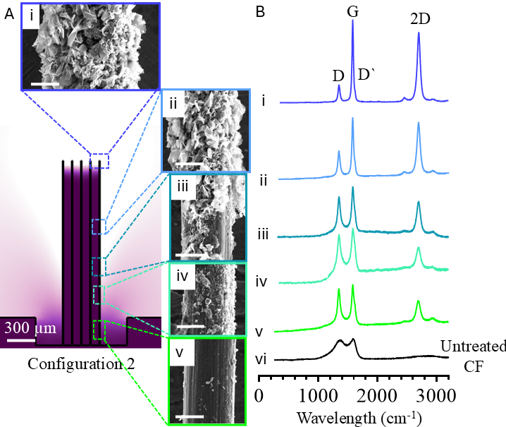
Figure 5. Raman Spectrum (B) along the length of the electrode for the configuration 2 (0.3 mm lid with 2mm long electrodes). The SEM (A) and Raman show different growth regions along the length of the electrode (i-v), scale bars are 4 µm.

3.2.2 Plasma-based etching
To further demonstrate the potential of plasma control on MEA development, plasma etching techniques were tested to create functional electrode sites. To the best of our knowledge, this is the first time plasma, without a physical mask, has been used to expose active sites on CF electrodes. To investigate the effect of this configuration on the plasma removal of Parylene-C we first explored the use of standard RIE. We started with this technique as it has traditionally been used to etched Parylene-C in 2D lithography[12, 77, 106]. We found that using traditional RIE there was no evidence of plasma attenuation with the fibers and faraday cage with Configuration 2 (2- mm long fibers) and Configuration 3 (0.3- mm thick lid), as shown in Figure 6A. These samples (n=6) showed parylene was etched everywhere but where the titanium lid shielded the substrate, a clear bulk etch region was observed in the center of the array where the sample was exposed to the plasma as shown by the light regions in the figure. The two mechanisms by which the parylene is etched by the oxygen plasma in RIE is through the oxidative chemical etching of the parylene by the oxygen radicals within the plasma and by the physical bombardment of ions as a result of the DC power directing the ions towards the sample surface [41]. The plasma is thus generated by the RF EF that is present between the two electrode plates in the system, typically at the top and bottom of the chamber. Thus, this technique has been optimized to maximize directionality of the bombardment of the ions between the two electrode plates. This enhances the ability to etch all of the parylene or other materials that are being exposed from physical or photolithographic masks with high resolution resulting in small (µm) distinct 2D features. This is typically achieved by increasing the DC power to enhance the acceleration of ions in the plasma toward the sample. In this experiment, we used the minimum DC power required to sustain the plasma, to minimize this directionality and maximize chemical etching of the parylene by reactive species in the plasma. We hypothesize that this will minimize ion bombardment at the base of the electrodes, however, we found no evidence of three-dimensional control of the plasma using standard RIE methods. This outcome is expected, as these systems are designed to produce highly uniform plasma conditions across the chamber with minimal attenuation by the sample itself.
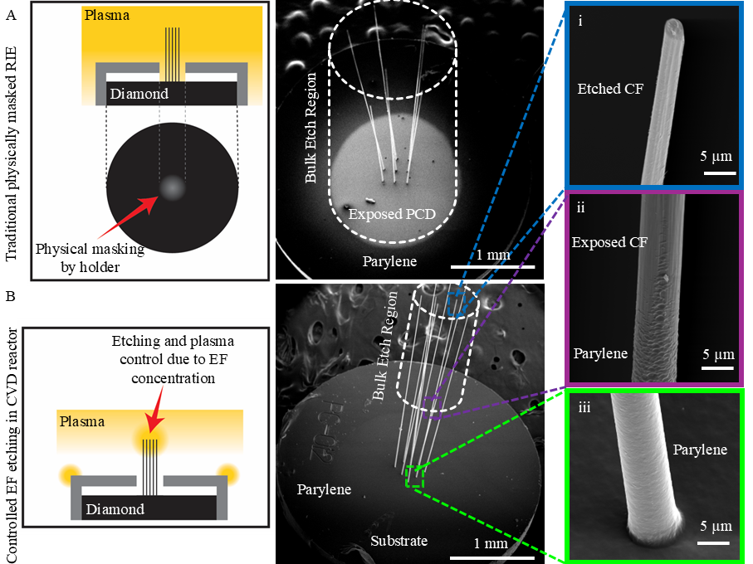
Figure 6. SEM images of MEAs after plasma etching. SEM of samples etched by RIE (A) and MP-CVD (B). The RIE sample shows bulk etching of the parylene everywhere not covered by the lid, indicating there was no curation of the plasma. The MP-CVD shows distinct etch regions, with the electrode tips (i), mid fiber (ii) and base of the sample (iii) experiencing distinct etching regions of the parylene and underlying fiber.
To establish control over oxygen plasma etching, we then attempted to etch Parylene-C using the MP-CVD reactor with an oxygen plasma, as we had previously demonstrated that EFs could be controlled in these systems. Unlike samples in the standard RIE, the MP-CVD oxygen plasma etching showed clear control of the plasma away from the surface of the substrate with no evidence of parylene etching being observed on the substrate of the CF-MEAs (Figure 6B). Like the MP-CVD growth samples, there appeared to be distinct regions of plasma intensities, with different etch rates being observed of the parylene along the length of the CF (Figure 6B, -i, -ii, -iii). Two configurations were tested: 2- and 0.3-mm lid thickness, both with 2- mm long electrodes. Both configurations showed no etching towards the base of the electrodes with parylene still being intact on the CF from the base of the sample up to 585±45 µm (n=4) and 222±52 µm (n=3) for the 2- and 0.3-mm lids, respectively. Etching was most pronounced at the tip of the electrodes, with bulk etching of the CFs occurring in these regions. Despite the very short etch time (30 seconds), a small, well-defined etch region was not achieved. This could potentially be addressed by using thicker parylene coatings so that only the fastest etch regions resulting in exposed EASs. This would also be increasing the coating thickness at the base of the electrode which could potentially improve the mechanical performance of the electrodes during implantation [107]. However, optimization of the coating thickness was beyond the scope of this work and represents an area for future investigation. The aim of this study was to confirm control of the EF within the MP-CVD reactor using the sample configuration itself, demonstrating that selective three-dimensional plasma-based subtractive fabrication is achievable.
To demonstrate how this could translate into a functional device, a laser was used to remove the excessively etched CF tips yielding a device with control exposure area at tip, as shown in Figure S10. Through a combination of imaging and selective cutting, a controllable length of CF can be left behind after the process for the desired use. This does mean that the length of the electrode in the final MEA design will be determined by the length of parylene that is able to be shielded from etching and the desired length of the active electrode site. Further investigation into the attenuation of the MP-CVD plasma etching will allow for more variety in electrode lengths and design. Currently, it appears that every area exposed to plasma will be etched, and more controlled etch rate could result in slower rates of Parylene-C etching and selective etching at the tips. Nevertheless, our results provide a proof-of-principle for using MP-CVD to selectively remove Parylen-C to produce functional MEAs [46, 47, 108].
4. Conclusion
In this work, we establish a strategy for spatially selective plasma processing that enables controlled surface modification of complex 3D microstructures. We demonstrate this strategy via the electrode site modification of 3D M-MEAs. Using COMSOL simulations, we designed titanium holder geometries that shape and confine microwave plasma within an MP-CVD chamber. By tuning electrode length and incorporating shielding lids, plasma exposure can be localised to targeted regions while protecting surrounding surfaces. This geometry-guided approach allows the electrodes themselves to concentrate the EF at their tips and promote site-specific deposition and etching. Proof-of-concept experiments confirmed the modelling predictions, demonstrating both localized B-NCD or CNW deposition and selective Parylene-C removal, and producing distinct, well-defined electrode active regions. Future work will focus on refining process parameters (e.g microwave power) to enhance precision and scalability. Although demonstrated using MEAs, the methods provide a general framework for additive and subtractive plasma fabrication on non-planar and high-aspect-ratio 3D microstructures.

Acknowledgements
This work was performed in part at the Melbourne Centre for Nanofabrication (MCN) in the Victorian Node of the Australian National Fabrication Facility (ANFF).

The authors acknowledge the facilities, and the scientific and technical assistance of the RMIT Microscopy & Microanalysis Facility (RMMF), a linked laboratory of Microscopy Australia, enabled by NCRIS.

References
[1] T. J. Oxley et al., "The ‘Brussels 4’: essential requirements for implantable brain–computer interface user autonomy," Journal of neural engineering, vol. 22, no. 1, p. 13002, 2025, doi: 10.1088/1741-2552/ada0e6.
[2] T. J. Oxley et al., "Motor neuroprosthesis implanted with neurointerventional surgery improves capacity for activities of daily living tasks in severe paralysis: first in-human experience," Journal of NeuroInterventional Surgery, vol. 13, no. 2, p. 102, 2021, doi: 10.1136/neurintsurg-2020-016862.
[3] R. Mackenzie. "How Can We Make It Easier To Implant a Brain-Computer Interface?" Technology Networks. https://www.technologynetworks.com/neuroscience/blog/how-can-we-make-it-easier-to-implant-a-brain-computer-interface-352026 (accessed 2022).
[4] J. J. Jun et al., "Fully integrated silicon probes for high-density recording of neural activity," Nature (London), vol. 551, no. 7679, pp. 232-236, 2017, doi: 10.1038/nature24636.
[5] J. E. Chung et al., "High-density single-unit human cortical recordings using the Neuropixels probe," Neuron (Cambridge, Mass.), vol. 110, no. 15, pp. 2409-2421.e3, 2022, doi: 10.1016/j.neuron.2022.05.007.
[6] A. C. Paulk et al., "Large-scale neural recordings with single neuron resolution using Neuropixels probes in human cortex," Nature neuroscience, vol. 25, no. 2, pp. 252-263, 2022, doi: 10.1038/s41593-021-00997-0.
[7] N. A. Steinmetz et al., "Neuropixels 2.0: A miniaturized high-density probe for stable, long-term brain recordings," Science (American Association for the Advancement of Science), vol. 372, no. 6539, p. 258, 2021, doi: 10.1126/science.abf4588.
[8] J. Putzeys et al., "Neuropixels Data-Acquisition System: A Scalable Platform for Parallel Recording of 10 000+ Electrophysiological Signals," IEEE transactions on biomedical circuits and systems, vol. 13, no. 6, pp. 1635-1644, 2019, doi: 10.1109/TBCAS.2019.2943077.
[9] H. Xu, A. W. Hirschberg, K. Scholten, T. W. Berger, D. Song, and E. Meng, "Acute in vivo testing of a conformal polymer microelectrode array for multi-region hippocampal recordings," Journal of neural engineering, vol. 15, no. 1, pp. 016017-016017, 2018, doi: 10.1088/1741-2552/aa9451.
[10] T. Wang, Y. Xi, M. Hu, B. Yang, W. Liu, and J. Liu, "Flexible, Reusable and Ultra-Thin Parylene-C/Cr Shadow Mask for Versatile Micropatterning Applications on Planar and Nonplanar Surfaces," Journal of microelectromechanical systems, vol. 27, no. 4, pp. 698-705, 2018, doi: 10.1109/JMEMS.2018.2844326.
[11] B. J. Kim and E. Meng, "Micromachining of Parylene C for bioMEMS," Polymers for advanced technologies, vol. 27, no. 5, pp. 564-576, 2016, doi: 10.1002/pat.3729.
[12] E. Meng, P.-Y. Li, and Y.-C. Tai, "Plasma removal of Parylene C," Journal of micromechanics and microengineering, vol. 18, no. 4, pp. 045004-045004 (13), 2008, doi: 10.1088/0960-1317/18/4/045004.
[13] Z. Zhao, X. Li, F. He, X. Wei, S. Lin, and C. Xie, "Parallel, minimally-invasive implantation of ultra-flexible neural electrode arrays," Journal of neural engineering, vol. 16, no. 3, pp. 35001-035001, 2019, doi: 10.1088/1741-2552/ab05b6.
[14] H. Shin et al., "Multifunctional multi-shank neural probe for investigating and modulating long-range neural circuits in vivo," Nature communications, vol. 10, no. 1, pp. 3777-11, 2019, doi: 10.1038/s41467-019-11628-5.
[15] K. Srikantharajah et al., "Minimally-invasive insertion strategy and in vivo evaluation of multi-shank flexible intracortical probes," Scientific reports, vol. 11, no. 1, pp. 18920-18920, 2021, doi: 10.1038/s41598-021-97940-x.
[16] H. Lee, R. V. Bellamkonda, W. Sun, and M. E. Levenston, "Biomechanical analysis of silicon microelectrode-induced strain in the brain," (in eng), J Neural Eng, vol. 2, no. 4, pp. 81-9, Dec 2005, doi: 10.1088/1741-2560/2/4/003.
[17] M. Ferguson, D. Sharma, D. Ross, and F. Zhao, "A Critical Review of Microelectrode Arrays and Strategies for Improving Neural Interfaces," (in eng), Adv Healthc Mater, vol. 8, no. 19, p. e1900558, Oct 2019, doi: 10.1002/adhm.201900558.
[18] R. Fiáth et al., "Recording site placement on planar silicon-based probes affects signal quality in acute neuronal recordings," Scientific Reports, vol. 11, no. 1, p. 2028, 2021/01/21 2021, doi: 10.1038/s41598-021-81127-5.
[19] J. Pas et al., "A bilayered PVA/PLGA-bioresorbable shuttle to improve the implantation of flexible neural probes," Journal of neural engineering, vol. 15, no. 6, pp. 065001-065001, 2018, doi: 10.1088/1741-2552/aadc1d.
[20] N. Sharafkhani, J. M. Long, S. D. Adams, and A. Z. Kouzani, "A binary stiffness compliant neural microprobe," Sensors and actuators. A. Physical., vol. 363, p. 114759, 2023, doi: 10.1016/j.sna.2023.114759.
[21] M. Cerezo-Sanchez et al., "Bioresorbable Insertion Aids for Brain Implantable Flexible Probes: A Comparative Study on Silk Fibroin, Alginate, and Disaccharides," Advanced NanoBiomed Research (Online), vol. 3, no. 9, p. n/a, 2023, doi: 10.1002/anbr.202200117.
[22] T. D. Kozai et al., "Chronic tissue response to carboxymethyl cellulose based dissolvable insertion needle for ultra-small neural probes," (in eng), Biomaterials, vol. 35, no. 34, pp. 9255-68, Nov 2014, doi: 10.1016/j.biomaterials.2014.07.039.
[23] S. Rezaei, Y. Xu, and S. W. Pang, "Control of neural probe shank flexibility by fluidic pressure in embedded microchannel using PDMS/PI hybrid substrate," PloS one, vol. 14, no. 7, pp. e0220258-e0220258, 2019, doi: 10.1371/journal.pone.0220258.
[24] S. E. De León, S. Higham, Y. J. Jung, W. Tong, and D. J. Garrett, "Recent developments in microwire-structured intracortical electrode arrays for brain–machine interfaces," Bioengineering & Translational Medicine, vol. n/a, no. n/a, p. e10742, doi: https://doi.org/10.1002/btm2.10742.
[25] N. F. Nolta, M. B. Christensen, P. D. Crane, J. L. Skousen, and P. A. Tresco, "BBB leakage, astrogliosis, and tissue loss correlate with silicon microelectrode array recording performance," Biomaterials, vol. 53, pp. 753-762, 2015, doi: 10.1016/j.biomaterials.2015.02.081.
[26] B. J. Black et al., "Chronic recording and electrochemical performance of Utah microelectrode arrays implanted in rat motor cortex," Journal of neurophysiology, vol. 120, no. 4, pp. 2083-2090, 2018, doi: 10.1152/jn.00181.2018.
[27] P. J. Rousche and R. A. Normann, "Chronic recording capability of the Utah Intracortical Electrode Array in cat sensory cortex," Journal of Neuroscience Methods, vol. 82, no. 1, pp. 1-15, 1998/07/01/ 1998, doi: https://doi.org/10.1016/S0165-0270(98)00031-4.
[28] K. Woeppel et al., "Explant analysis of Utah electrode arrays implanted in human cortex for brain-computer-interfaces," medRxiv, p. 2021.08.28.21262765, 2021, doi: 10.1101/2021.08.28.21262765.
[29] I. N. McNamara et al., "Electrode sharpness and insertion speed reduce tissue damage near high-density penetrating arrays," Journal of neural engineering, 2024.
[30] Y. Huan et al., "Carbon fiber electrodes for intracellular recording and stimulation," (in eng), J Neural Eng, vol. 18, no. 6, Dec 14 2021, doi: 10.1088/1741-2552/ac3dd7.
[31] M. Welkenhuysen, A. Andrei, L. Ameye, W. Eberle, and B. Nuttin, "Effect of insertion speed on tissue response and insertion mechanics of a chronically implanted silicon-based neural probe," IEEE Trans Biomed Eng, vol. 58, no. 11, pp. 3250-9, Nov 2011, doi: 10.1109/TBME.2011.2166963.
[32] A. Obaid et al., "Massively parallel microwire arrays integrated with CMOS chips for neural recording," Science Advances, vol. 6, no. 12, p. eaay2789, doi: 10.1126/sciadv.aay2789.
[33] D. Prodanov and J. Delbeke, "Mechanical and biological interactions of implants with the brain and their impact on implant design," Frontiers in neuroscience, vol. 10, pp. 11-11, 2016, doi: 10.3389/fnins.2016.00011.
[34] D. A. Bjånes et al., "Quantifying physical degradation alongside recording and stimulation performance of 980 intracortical microelectrodes chronically implanted in three humans for 956-2246 days," Acta biomaterialia, 2025, doi: 10.1016/j.actbio.2025.02.030.
[35] K. Zhang et al., "Investigating Communication Dynamics in Neuronal Network using 3D Gold Microelectrode Arrays," ACS Nano, vol. 18, no. 26, pp. 17162-17174, 2024/07/02 2024, doi: 10.1021/acsnano.4c03983.
[36] D. Yoon and Y. Nam, "A 3D neuronal network read-out interface with high recording performance using a neuronal cluster patterning on a microelectrode array," Biosensors and Bioelectronics, vol. 261, p. 116507, 2024/10/01/ 2024, doi: https://doi.org/10.1016/j.bios.2024.116507.
[37] K. Nojiri, Dry Etching Technology for Semiconductors, 1st 2015. ed. Cham: Springer International Publishing, 2015.
[38] K. Edalati et al., "Effective removal of metal-carbide contamination from diamond circuit boards by reactive ion etching," Diamond and Related Materials, p. 110329, 2023.
[39] N. Lim, A. Efremov, B. Woo, and K. H. Kwon, "Comparative study of CF4 + O2 and C6F12O + O2 plasmas for reactive‐ion etching applications," Plasma processes and polymers, vol. 19, no. 2, p. n/a, 2022, doi: 10.1002/ppap.202100129.
[40] K.-C. Chien and C.-H. Chang, "Controlling the etch selectivity of silicon using low-RF power HBr reactive ion etching," Journal of vacuum science and technology. B, Nanotechnology & microelectronics, vol. 40, no. 6, 2022, doi: 10.1116/6.0002109.
[41] A. Lecomte et al., "Deep plasma etching of Parylene C patterns for biomedical applications," Microelectronic engineering, vol. 177, pp. 70-73, 2017, doi: 10.1016/j.mee.2017.02.012.
[42] B. W. K. Woo, S. C. Gott, R. A. Peck, D. Yan, M. W. Rommelfanger, and M. P. Rao, "Ultrahigh Resolution Titanium Deep Reactive Ion Etching," ACS applied materials & interfaces, vol. 9, no. 23, pp. 20161-20168, 2017, doi: 10.1021/acsami.6b16518.
[43] R. Tang, J. Zhang, J. Du, and W. Wang, "Diamond ICP-DRIE etching technology with PECVD SiO2 as mask," Journal of micromechanics and microengineering, vol. 35, no. 11, 2025, doi: 10.1088/1361-6439/ae1483.
[44] X. Xie et al., "Long-term reliability of Al2O3 and Parylene C bilayer encapsulated Utah electrode array based neural interfaces for chronic implantation," Journal of neural engineering, vol. 11, no. 2, pp. 026016-026016, 2014, doi: 10.1088/1741-2560/11/2/026016.
[45] J.-M. Hsu, L. Rieth, R. A. Normann, P. Tathireddy, and F. Solzbacher, "Encapsulation of an Integrated Neural Interface Device With Parylene C," IEEE transactions on biomedical engineering, vol. 56, no. 1, pp. 23-29, 2009, doi: 10.1109/TBME.2008.2002155.
[46] G. Guitchounts, J. E. Markowitz, W. A. Liberti, and T. J. Gardner, "A carbon-fiber electrode array for long-term neural recording," (in eng), Journal of neural engineering, vol. 10, no. 4, pp. 046016-046016, 2013, doi: 10.1088/1741-2560/10/4/046016.
[47] T. Dong, L. Chen, and A. Shih, "Laser Sharpening of Carbon Fiber Microelectrode Arrays for Brain Recording," presented at the ASME 2020 15th International Manufacturing Science and Engineering Conference, 2020. [Online]. Available: https://doi.org/10.1115/MSEC2020-8479.
[48] O. A. Shenderova and D. M. Gruen, Ultrananocrystalline diamond synthesis, properties, and applications (Materials science and process technology series). Norwich, N.Y: William Andrew Pub., 2006.
[49] S. Mandal et al., "Thick, Adherent Diamond Films on AlN with Low Thermal Barrier Resistance," (in eng), ACS Appl Mater Interfaces, vol. 11, no. 43, pp. 40826-40834, Oct 30 2019, doi: 10.1021/acsami.9b13869.
[50] W. Tong, K. Fox, K. Ganesan, and S. Prawer, "Design of a Patterned Diamond Substrate for Ordered Neural Cell Adhesion," Procedia Technology, vol. 20, pp. 206-211, 2015/01/01/ 2015, doi: https://doi.org/10.1016/j.protcy.2015.07.033.
[51] R. Trouillon and D. O’Hare, "Comparison of glassy carbon and boron doped diamond electrodes: Resistance to biofouling," Electrochimica Acta, vol. 55, no. 22, pp. 6586-6595, 2010/09/01/ 2010, doi: https://doi.org/10.1016/j.electacta.2010.06.016.
[52] O. Auciello, S. Renou, K. Kang, D. Tasat, and D. Olmedo, "A Biocompatible Ultrananocrystalline Diamond (UNCD) Coating for a New Generation of Dental Implants," (in eng), Nanomaterials (Basel), vol. 12, no. 5, Feb 25 2022, doi: 10.3390/nano12050782.
[53] S. K. Smart, A. I. Cassady, G. Q. Lu, and D. J. Martin, "The biocompatibility of carbon nanotubes," Carbon, vol. 44, no. 6, pp. 1034-1047, 2006/05/01/ 2006, doi: https://doi.org/10.1016/j.carbon.2005.10.011.
[54] A. Voss et al., "Influence of the surface termination of ultrananocrystalline diamond/amorphous carbon composite films on their interaction with neurons," Diamond and Related Materials, vol. 26, pp. 60-65, 2012/06/01/ 2012, doi: https://doi.org/10.1016/j.diamond.2012.04.005.
[55] W. Yang et al., "Relationship between substrate type and BDD electrode structure, performance and antibiotic tetracycline mineralization," Journal of Alloys and Compounds, vol. 890, p. 161760, 2022/01/15/ 2022, doi: https://doi.org/10.1016/j.jallcom.2021.161760.
[56] O. Auciello and A. V. Sumant, "Status review of the science and technology of ultrananocrystalline diamond (UNCD™) films and application to multifunctional devices," Diamond and Related Materials, vol. 19, no. 7, pp. 699-718, 2010/07/01/ 2010, doi: https://doi.org/10.1016/j.diamond.2010.03.015.
[57] S. Nad and J. Asmussen, "Analyses of single crystal diamond substrates grown in a pocket substrate holder via MPACVD," Diamond and related materials, vol. 66, pp. 36-46, 2016, doi: 10.1016/j.diamond.2016.03.007.
[58] V. S. Sedov, A. K. Martyanov, A. A. Khomich, S. S. Savin, E. V. Zavedeev, and V. G. Ralchenko, "Deposition of diamond films on Si by microwave plasma CVD in varied CH4-H2 mixtures: Reverse nanocrystalline-to-microcrystalline structure transition at very high methane concentrations," Diamond and related materials, vol. 109, p. 108072, 2020, doi: 10.1016/j.diamond.2020.108072.
[59] J. Shalini et al., "Ultra-nanocrystalline diamond nanowires with enhanced electrochemical properties," Electrochimica Acta, vol. 92, pp. 9-19, 2013/03/01/ 2013, doi: https://doi.org/10.1016/j.electacta.2012.12.078.
[60] K. J. Sankaran, P. T. Joseph, H. C. Chen, N. H. Tai, and I. N. Lin, "Investigation in the role of hydrogen on the properties of diamond films grown using Ar/H2/CH4 microwave plasma," Diamond and Related Materials, vol. 20, no. 2, pp. 232-237, 2011/02/01/ 2011, doi: https://doi.org/10.1016/j.diamond.2010.12.018.
[61] A. V. Sumant, O. Auciello, R. W. Carpick, S. Srinivasan, and J. E. Butler, "Ultrananocrystalline and Nanocrystalline Diamond Thin Films for MEMS/NEMS Applications," MRS Bulletin, vol. 35, no. 4, pp. 281-288, 2010/04/01 2010, doi: 10.1557/mrs2010.550.
[62] H. F. Cheng, C.-C. Horng, H.-Y. Chiang, H.-C. Chen, and I.-N. Lin, "Modification on the Microstructure of Ultrananocrystalline Diamond Films for Enhancing Their Electron Field Emission Properties via a Two-Step Microwave Plasma Enhanced Chemical Vapor Deposition Process," Journal of Physical Chemistry C, vol. 115, pp. 13894-13900, 2011.
[63] S. A. Linnik, A. V. Gaydaychuk, and E. Y. Baryshnikov, "Deposition of Polycrystalline Diamond Films with a Controlled Grain Size by Periodic Secondary Nucleation," Materials Today: Proceedings, vol. 3, pp. S138-S144, 2016/01/01/ 2016, doi: https://doi.org/10.1016/j.matpr.2016.02.024.
[64] N. Wiora et al., "Grain boundary dominated electrical conductivity in ultrananocrystalline diamond," Journal of Applied Physics, vol. 122, p. 145102, 10/14 2017, doi: 10.1063/1.4993442.
[65] J. Birrell, J. A. Carlisle, O. Auciello, D. M. Gruen, and J. M. Gibson, "Morphology and electronic structure in nitrogen-doped ultrananocrystalline diamond," Applied physics letters, vol. 81, no. 12, pp. 2235-2237, 2002, doi: 10.1063/1.1503153.
[66] A. Vesel, R. Zaplotnik, G. Primc, and M. Mozetič, "Synthesis of Vertically Oriented Graphene Sheets or Carbon Nanowalls-Review and Challenges," (in eng), Materials (Basel), vol. 12, no. 18, Sep 12 2019, doi: 10.3390/ma12182968.
[67] J. Chen, Z. Bo, and G. Lu, "PECVD Synthesis of Vertically-Oriented Graphene: Precursor and Temperature Effects," in Vertically-Oriented Graphene: PECVD Synthesis and Applications, J. Chen, Z. Bo, and G. Lu Eds. Cham: Springer International Publishing, 2015, pp. 35-54.
[68] Y. Yerlanuly et al., "Physical properties of carbon nanowalls synthesized by the ICP-PECVD method vs. the growth time," Scientific Reports, vol. 11, no. 1, p. 19287, 2021/09/29 2021, doi: 10.1038/s41598-021-97997-8.
[69] M. Hiramatsu, K. Shiji, H. Amano, and M. Hori, "Fabrication of vertically aligned carbon nanowalls using capacitively coupled plasma-enhanced chemical vapor deposition assisted by hydrogen radical injection," Applied Physics Letters, vol. 84, no. 23, pp. 4708-4710, 2004, doi: 10.1063/1.1762702.
[70] Z. Zhai et al., "Insight into the Effect of the Core–Shell Microstructure on the Electrochemical Properties of Undoped 3D-Networked Conductive Diamond/Graphite," The Journal of Physical Chemistry C, vol. 123, no. 10, pp. 6018-6029, 2019/03/14 2019, doi: 10.1021/acs.jpcc.8b11865.
[71] D. V. Nechaev and A. F. Khokhryakov, "Formation of metastable graphite inclusions during diamond crystallization in model systems," Geology of ore deposits, vol. 56, no. 2, pp. 139-146, 2014, doi: 10.1134/S1075701514020044.
[72] C. Hua, J. Cai, L. Li, P. Pan, and J. Feng, "Controllable synthesis of diamond/graphite composite films with tunable dielectric properties for microwave attenuation," Diamond and Related Materials, vol. 138, p. 110242, 2023/10/01/ 2023, doi: https://doi.org/10.1016/j.diamond.2023.110242.
[73] X. Zhang et al., "Synthesis of graphene interlayer diamond films for enhanced electrochemical performance," Carbon (New York), vol. 196, pp. 602-611, 2022, doi: 10.1016/j.carbon.2022.05.038.
[74] M. Schreck, S. Gsell, R. Brescia, and M. Fischer, "Ion bombardment induced buried lateral growth: The key mechanism for the synthesis of single crystal diamond wafers," Scientific reports, vol. 7, no. 1, pp. 44462-44462, 2017, doi: 10.1038/srep44462.
[75] A. P. Bolshakov et al., "Enhanced deposition rate of polycrystalline CVD diamond at high microwave power densities," Diamond and related materials, vol. 97, p. 107466, 2019, doi: 10.1016/j.diamond.2019.107466.
[76] I. Yagi, K. Tsunozaki, A. Fujishima, B. Ohtani, and K. Uosaki, "The effects of nitrogen and plasma power on electrochemical properties of boron-doped diamond electrodes grown by MPCVD," Journal of the Electrochemical Society, vol. 149, no. 1, pp. E1-E5, 2002, doi: 10.1149/1.1425795.
[77] C. Vallée et al., "Plasma deposition—Impact of ions in plasma enhanced chemical vapor deposition, plasma enhanced atomic layer deposition, and applications to area selective deposition," Journal of vacuum science & technology. A, Vacuum, surfaces, and films, vol. 38, no. 3, 2020, doi: 10.1116/1.5140841.
[78] P. O. Oviroh, R. Akbarzadeh, D. Pan, R. A. M. Coetzee, and T.-C. Jen, "New development of atomic layer deposition: processes, methods and applications," Science and technology of advanced materials, vol. 20, no. 1, pp. 465-496, 2019, doi: 10.1080/14686996.2019.1599694.
[79] V. Sedov et al., "Effect of substrate holder design on stress and uniformity of large-area polycrystalline diamond films grown by microwave plasma-assisted cvd," Coatings (Basel), vol. 10, no. 10, pp. 1-10, 2020, doi: 10.3390/coatings10100939.
[80] A. Charris, S. Nad, and J. Asmussen, "Exploring constant substrate temperature and constant high pressure SCD growth using variable pocket holder depths," Diamond and related materials, vol. 76, pp. 58-67, 2017, doi: 10.1016/j.diamond.2017.04.010.
[81] E. E. Ashkihazi et al., "Plateholder design for deposition of uniform diamond coatings on WC-Co substrates by microwave plasma CVD for efficient turning application," Diamond and related materials, vol. 75, pp. 169-175, 2017, doi: 10.1016/j.diamond.2017.04.011.
[82] S. Nad, Y. Gu, and J. Asmussen, "Growth strategies for large and high quality single crystal diamond substrates," Diamond and Related Materials, vol. 60, pp. 26-34, 2015/11/01/ 2015, doi: https://doi.org/10.1016/j.diamond.2015.09.018.
[83] N. Li, Z. Zhen, Z. Xu, R. Zhang, R. Mu, and L. He, "The growth of large-sized graphene domains by Faraday cage-assisted plasma enhanced chemical vapor deposition," Applied surface science advances, vol. 6, p. 100154, 2021, doi: 10.1016/j.apsadv.2021.100154.
[84] C. Ma et al., "Plasma-enhanced chemical vapor deposition of graphene on dielectric substrate in Faraday cage: a kinetic study," Materials research express, vol. 6, no. 4, p. 45604, 2019, doi: 10.1088/2053-1591/aaf917.
[85] M. A. Hejazi et al., "Hybrid diamond/ carbon fiber microelectrodes enable multimodal electrical/chemical neural interfacing," Biomaterials, vol. 230, p. 119648, 2020/02/01/ 2020, doi: https://doi.org/10.1016/j.biomaterials.2019.119648.
[86] Y. Jiang et al., "Enhanced boron doping for diamond growth in cylindrical CVD reactors using a Faraday cage," Diamond and Related Materials, vol. 160, p. 113009, 2025/12/01/ 2025, doi: https://doi.org/10.1016/j.diamond.2025.113009.
[87] J. A. Cuenca et al., "Microwave plasma modelling for thick diamond deposition on III-nitrides," Carbon (New York), vol. 241, p. 120349, 2025, doi: 10.1016/j.carbon.2025.120349.
[88] S. Higham et al., "Carbon Cybernetics Array: a miniaturized carbon-based microelectrode array for intracortical recording," bioRxiv, p. 2026.01.06.696090, 2026, doi: 10.64898/2026.01.06.696090.
[89] P. R. Patel et al., "High density carbon fiber arrays for chronic electrophysiology, fast scan cyclic voltammetry, and correlative anatomy," (in eng), J Neural Eng, vol. 17, no. 5, p. 056029, Oct 15 2020, doi: 10.1088/1741-2552/abb1f6.
[90] E. J. Welle et al., "Sharpened and Mechanically Durable Carbon Fiber Electrode Arrays for Neural Recording," IEEE transactions on neural systems and rehabilitation engineering, vol. 29, pp. 993-1003, 2021, doi: 10.1109/TNSRE.2021.3082056.
[91] "Multi-walled carbon nanotubes induce airway hyperresponsiveness in human bronchi by stimulating sensory C-fibers and increasing the release of neuronal acetylcholine," Expert review of respiratory medicine, pp. 1-9, 2021, doi: 10.1080/17476348.2021.1979395.
[92] M. A. Hejazi et al., "High Fidelity Bidirectional Neural Interfacing with Carbon Fiber Microelectrodes Coated with Boron‐Doped Carbon Nanowalls: An Acute Study," Advanced functional materials, vol. 30, no. 52, pp. 2006101-n/a, 2020, doi: 10.1002/adfm.202006101.
[93] S. J. Higham et al., "Boron-Doped Nano-Crystalline Coated Carbon Fibers for Phasic Dopamine Sensing," Advanced Healthcare Materials, vol. n/a, no. n/a, p. e03945, 2025/12/18 2025, doi: https://doi.org/10.1002/adhm.202503945.
[94] B. P. Chaplin, I. Wyle, H. Zeng, J. A. Carlisle, and J. Farrell, "Characterization of the performance and failure mechanisms of boron-doped ultrananocrystalline diamond electrodes," Journal of Applied Electrochemistry, vol. 41, no. 11, pp. 1329-1340, 2011/11/01 2011, doi: 10.1007/s10800-011-0351-7.
[95] X.-R. Lu, M.-H. Ding, C. Zhang, and W.-Z. Tang, "Comparative study on stability of boron doped diamond coated titanium and niobium electrodes," Diamond and related materials, vol. 93, pp. 26-33, 2019, doi: 10.1016/j.diamond.2019.01.010.
[96] K. Edalati et al., "Improved wetting of gold active braze alloy on diamond for use in medical implants," DIAMOND AND RELATED MATERIALS, vol. 109, NOV 2020, doi: 10.1016/j.diamond.2020.108089.
[97] N. V. Apollo et al., "Brazing techniques for the fabrication of biocompatible carbon-based electronic devices," Carbon, vol. 107, pp. 180-189, 2016/10/01/ 2016, doi: https://doi.org/10.1016/j.carbon.2016.05.047.
[98] S. S. Oishi, L. M. Silva, E. C. Botelho, M. C. Rezende, C. A. A. Cairo, and N. G. Ferreira, "Influence of modified carbon substrate on boron doped ultrananocrystalline diamond deposition," Materials Research Express, vol. 5, no. 2, p. 26405, 2018, doi: 10.1088/2053-1591/aaaa82.
[99] J. Millán-Barba et al., "Boron-doped diamond growth on carbon fibre: Enhancing the electrical conductivity," Applied Surface Science, vol. 615, p. 156382, 2023/04/01/ 2023, doi: https://doi.org/10.1016/j.apsusc.2023.156382.
[100] F. Silva, K. Hassouni, X. Bonnin, and A. Gicquel, "Microwave engineering of plasma-assisted CVD reactors for diamond deposition," Journal of Physics: Condensed Matter, vol. 21, no. 36, p. 364202, 2009/08/19 2009, doi: 10.1088/0953-8984/21/36/364202.
[101] E. L. Silva et al., "Direct Synthesis of Electrowettable Carbon Nanowall–Diamond Hybrid Materials from Sacrificial Ceramic Templates Using HFCVD," Advanced Materials Interfaces, vol. 4, no. 10, p. 1700019, 2017, doi: https://doi.org/10.1002/admi.201700019.
[102] J. Millán-Barba et al., "Study of Early Stages in the Growth of Boron‐Doped Diamond on Carbon Fibers," Physica status solidi. A, Applications and materials science, vol. 218, no. 5, p. n/a, 2021, doi: 10.1002/pssa.202000284.
[103] S. Garcia-Segura, E. Vieira Dos Santos, and C. A. Martínez-Huitle, "Role of sp/sp ratio on the electrocatalytic properties of boron-doped diamond electrodes: A mini review," Electrochemistry communications, vol. 59, pp. 52-55, 2015, doi: 10.1016/j.elecom.2015.07.002.
[104] M. Hejazi, W. Tong, M. R. Ibbotson, S. Prawer, and D. J. Garrett, "Advances in Carbon-Based Microfiber Electrodes for Neural Interfacing," (in eng), Front Neurosci, vol. 15, p. 658703, 2021, doi: 10.3389/fnins.2021.658703.
[105] M. Sobaszek et al., "Diamond Phase (sp3 -C) Rich Boron-Doped Carbon Nanowalls (sp2 -C): Physicochemical and Electrochemical Properties," Journal of physical chemistry. C, vol. 121, no. 38, pp. 20821-20833, 2017, doi: 10.1021/acs.jpcc.7b06365.
[106] L. Zhang, Y. Liu, Z. Li, and W. Wang, "SF6 Optimized O2 Plasma Etching of Parylene C," Micromachines, vol. 9, no. 4, p. 162, 2018. [Online]. Available: https://www.mdpi.com/2072-666X/9/4/162.
[107] S. P. Marshall, W. Lin, P. R. Patel, A. J. Shih, and C. A. Chestek, "Effects of geometry and material on the insertion oi very small neural electrode," in 2016 38th Annual International Conference of the IEEE Engineering in Medicine and Biology Society (EMBC), 16-20 Aug. 2016 2016, pp. 2784-2788, doi: 10.1109/EMBC.2016.7591308.
[108] X. Fu et al., "Carbon-Based Fiber Materials as Implantable Depth Neural Electrodes," (in eng), Front Neurosci, vol. 15, p. 771980, 2021, doi: 10.3389/fnins.2021.771980.

